

Programme Name: ________**BCS HONS**_______________________________________

Course Code: __**ISYS 2400**________

Course Name: _______**Management Information System**____________________________

Assignment/ Lab Sheet / **Project** / Case Study No. _**1**___

Date of Submission: ______**8/31/2021**_____________

**Submitted By: Submitted To:**

Student Name**: Dipesh Tha Shrestha** Faculty Name**: Satyam Paudel**

IUKL ID: **041902900028** Department**: LMS**

Semester**: Fourth Semester**

Intake**: September 2019**

|  |
| --- |
| **Case study on LG Electronics** |

**Table of Context**

**Introduction**

* **ERP**
* **About Company**
* LG Electronics
* Business Sites
* organizational structure
* Business Sites
* organizational Chart
* **Problems faced before implementing ERP**
* **Direct benefits provided after implementation of ERP**
* **Increased and efficiency after implementing ERP**
* Financial Report of LG
* Worldwide revenue of LG
* LG Employee Training Program
* Global Sales of LG
* Number of employee and their region of LG
* For Improvement
* **Challenges/Threat for LG Electronics**
* **Risk and Challenges with implementation of ERP**
* **Conclusion**

**Introduction**

**ERP (Enterprise Resource Planning)**

ERP stands for "Enterprise Resource Planning" and refers to a type of software or system used by a business to plan and manage daily activities such as supply chain, manufacturing, services, financials and other processes. Enterprise Resource Planning software can be used to automate and simplify individual activities across a business or organization, such as accounting and procurement, project management, customer relationship management, risk management, compliance, and supply chain operations.

**About Company**

LG is a South Korean electronics company founded as GoldStar in 1958 by Koo In-hwoi . After the Korean War, the company was founded to produce consumer electronics and home appliances for the local market. As a result, it was the first company in South Korea to manufacture radios, televisions, refrigerators, washing machines, and air conditioners. While the company was originally known as GoldStar, in 1995 it was merged with Lucky Chemical and LS Cable, two other LG group companies.

The company’s first overseas production facility was set up in the US in 1982. In 1994 GoldStar officially became LG Electronics. To expand its footprint in the US, LG acquired US-based television manufacturer Zenith and also launched the world’s first CDMA digital mobile phone in 1995. In 1999, the company made a joint venture with Philips, now known as LG Display, to design and develop liquid crystal displays (LCDs).

**Organizational structure**

LG is all known as “Life is Good” and “Lucky Goldstar”. With 82,000 employees in 114 subsidiaries across 39 countries, LG Electronics Inc. is one of the largest consumer electronics companies in the world. The company is known as a Digital Leader in electronic goods and equipment in this digital era with the company’s progression. Its diverse product range encompasses air conditioners, digital media, laptops, mobile phones, PC monitors, refrigerators, televisions, and more.

**Business Sites**

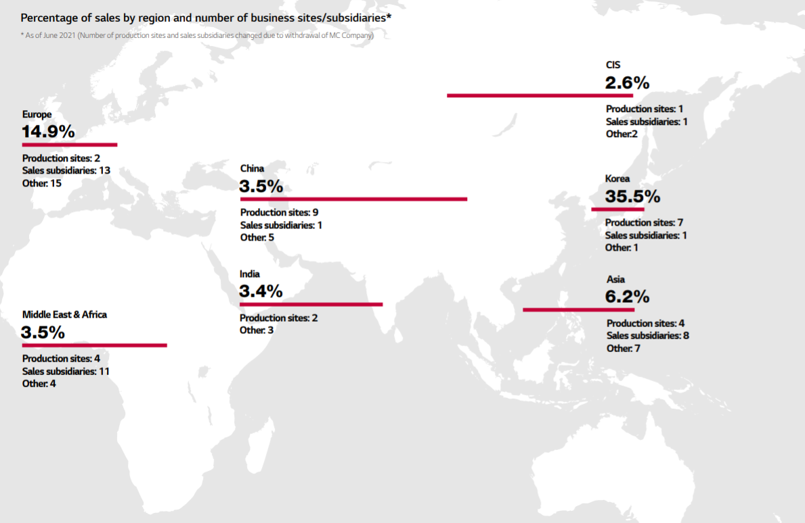Fig.1

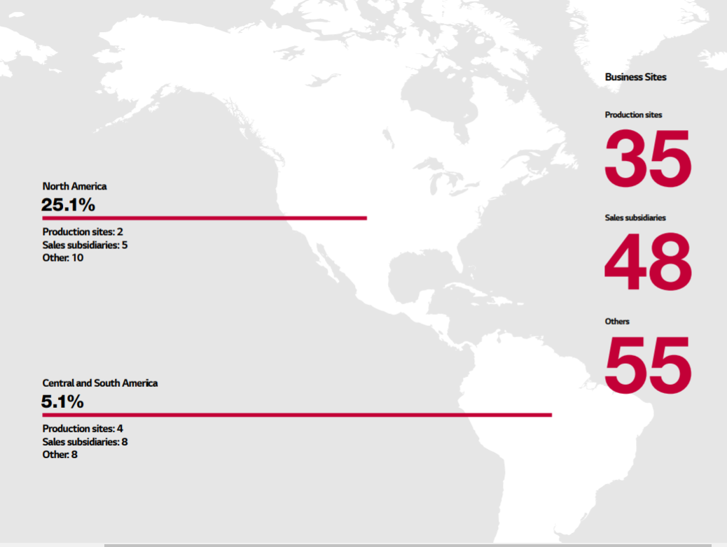Fig.2

**Fig.1 and Fig.2 show you the number of business sites of lG all over the world.**

**Organization Chart**

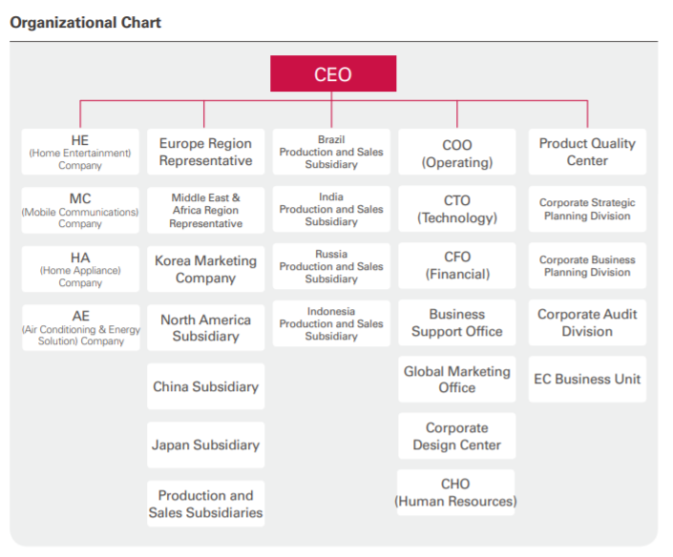

**Diagram: Organization Chart**

**Problems faced before implementing ERP**

As we know, LG has over 82000 employees in 114 subsidiaries across 39 countries. Its large number of employees worldwide tried to adapt to the functionalities of Human Resources. But its control over locals was lacking transparency and the maintenance cost was going over the top. Also, its rise in manual processes, non-proper utilization of its resources and decision-making inefficiency made it quite difficult for the company to act as a global company. In Simple, here are the problems faced before implementing ERP.

* Location specific multiple systems leading to unclear top-level reporting
* lack of optimum resource utilization / underuse of resources
* Location specific processes lacking transparency and automation needs for a global reporting
* Disengaged employees, limited outlook, no room for information or best practices sharing
* Limited localized resources for employee learning & training
* Challenges with decision making, with significant business impact
* high maintenance costs
* Because of its large presence in the white and brown goods market, they are unable to properly focus on each product category, and as a result, they are losing market share in several products such as televisions and refrigerators.
* Online Presence is very Low: LG Electronics is not having good presence in social media market.

**Direct benefits provided after implementation of ERP**

It was difficult for LG to have a smooth ERP solution implementation because of the sort of large business it operates.Nonetheless, with the help of ERP solutions, the company was able to achieve its objectives and reduce the challenges faced by its globally dispersed centers in the department of Human Resource management over a five-year period. The following are some of the advantages it has received:

* Better goal and objective tracking with real-time reporting of the higher management team
* Real-time reporting availability helped in the well-informed decision-making process
* Sounder HR functionality with improved efficiency
* Flexibility for regions into making changes locally due to control over the HR system centrally
* Time-efficient & cost saving
* It was not easy for LG, for the kind of large scale business it operates to have a smooth ERP solution implementation.
* But still, over a period of five years, the company managed to fulfill its objectives and minimize the challenges professed by its widely spread centers world-wide in the department of Human Resource management with the help of ERP solutions. The benefits it got include:
* Minimalistic maintenance cost with a single centrally managed system
* Employees got easy accessibility and self-service capacity
* Enhanced learning process among the employees via the sharing of documents, tutorials, etc. that led to time & cost savings
* Boosted productivity, engagement and morale of employees all over the company
* Improved transparency in recruitment & employee assessment program
* Various centers got to share all the best practices easily with each other

**Increased and efficiency after implementing ERP**

The Oracle E-Business Suite R12 was implemented fully in January 2009 and after 18 months of this transformation LG electronics was able to increase productivity by 30%, reduce manufacturing time by 50% and this made them reduce their cost to the customers by 30-50%, this definitely means that they made a competitive market with lesser cost to the consumers (Oracle, 2013). With their greater visibility of their global sales, marketing, inventories and other management operations they were able to reduce their management cost by 50% and their IT budget was also cut down to 20%. Due to the openness of the software better quality of service was provided. Their supply chain management also improved due to readily availability of data and analytics that can be performed with the lesser timespan (Evans, 2009) and (Essays, 2018). The business introduced functions to handle LG Display’s historical data, such as data history audit management, hierarchy and relationship management, and data enrichment functions. In addition, the expansion framework does not require hard coding, so that the company can easily add more than 20,000 properties to support expansion (Oracle, 2013).

**Total Revenue of LG**

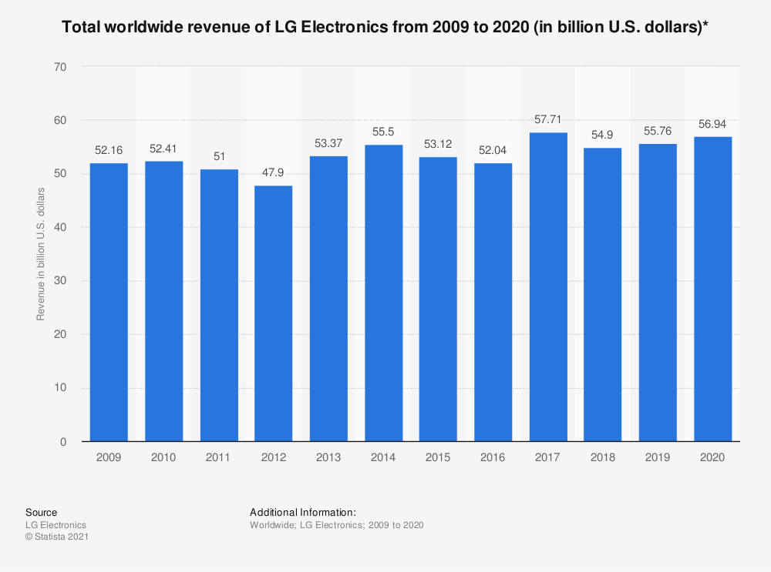

**Financial Performance of LG**

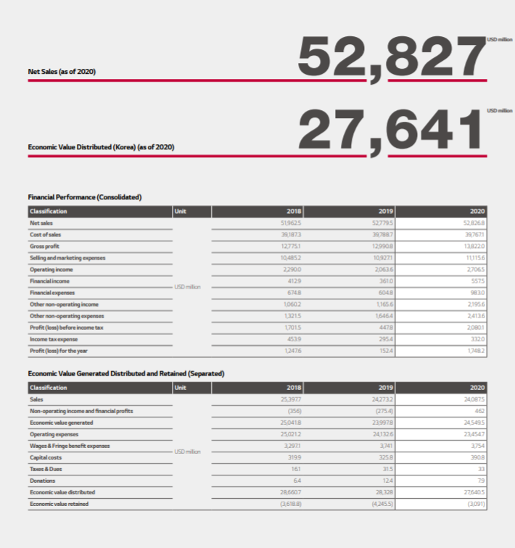

**Employee Training System**

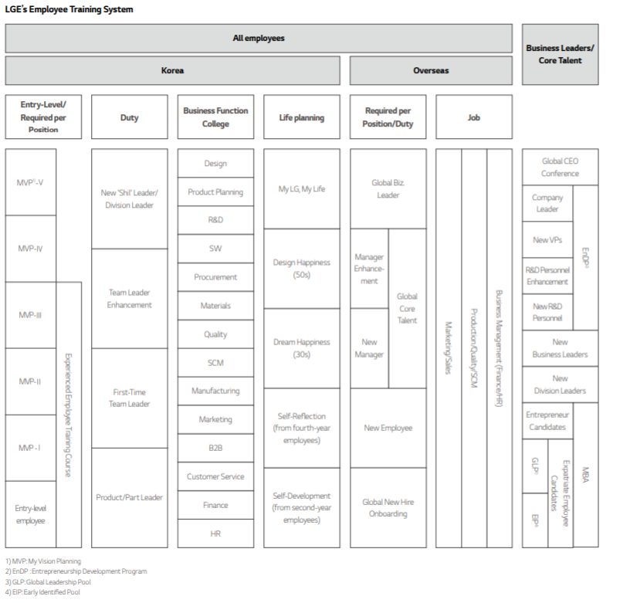

**Global Sales of LG**

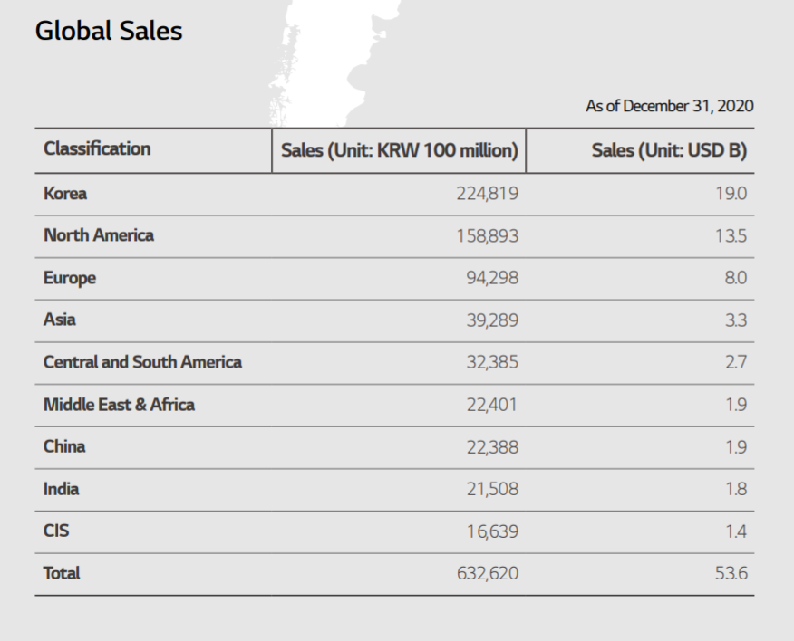

**Number of Employees of all the Region**

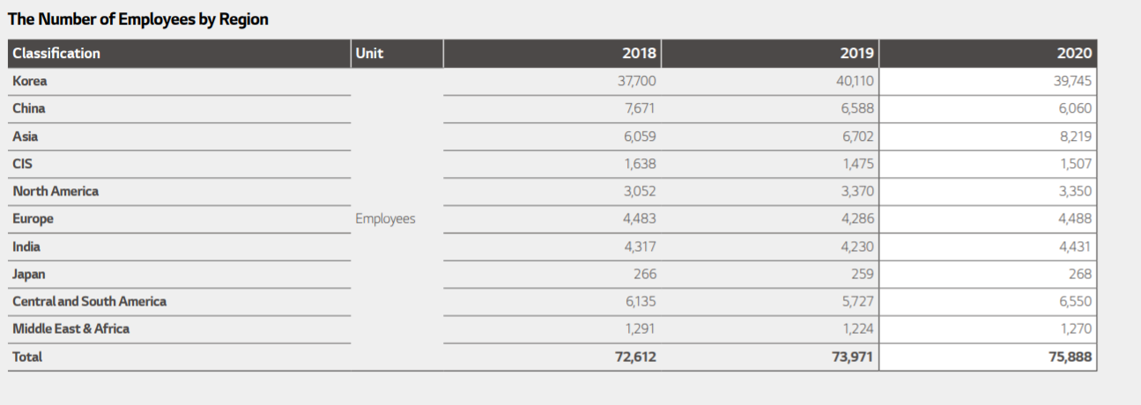

**For Improvement**

To provide a great service first the ERP must have complete control over its resources and projects to make sure scheduling is being done properly. There should be a billing system in the software as well as customers will have to be paid on various terms and billing rates should be carefully controlled and handled to ensure that the services provided are appropriately invoiced based on the time spent and the quality of service provided. The data was obtained from one module and then fed into the ERP CRM’s module. This also allowed them to gain control of the service levels of service engineers throughout the country. Also, LG released their customer delight campaign in which customers were provided with SMS services and voice of customer to take constant feedbacks. With the introduction of such service it boosts up the sales and benefitted them in long run. Moreover, there should be better visibility over its operations to make sure cost-effective decisions are made such as delivered a broken TV or wrong parcel, this causes extra surges hence ERP should be automated and fully controlled.

**Challenges/Thread for LG Electronics**

* Intense competition within the industry: Every company in this industry is fighting tooth and nail to establish a presence and maintain market share. The majority of industry players use a red ocean strategy to eliminate competition that is harming the industry as a whole.
* Stagnant urban demand dynamics: With more and more companies venturing into the overcrowded urban market, there is little room for growth in these markets, making overdependence on these markets riskier for LG.
* Government Regulations: Government policies relating to the use of innovative technology for energy and power conservation are affecting the industry in general and forcing them to switch to renewable energy sources.
* Sluggish Economy: Macroeconomic uncertainty, recession, lockdown, unemployment, COVID and other economic factors will continue to be a source of concern for the industry for some time.
* Rising raw material costs: LG's margins are shrinking as raw material and labor costs rise, making the company's operations less profitable.

**Risk with implementation of ERP**

* The possible failure or inability to align goals through conflicting directions within the organization.
* Maintenance difficulties may occur on bridged legacy systems.
* Previously used systems may be not compatible with the ERP
* ERP systems are frequently criticized because of their incompatibility with other IS application
* Company mays fails to maintain ERP-related knowledge and know-how accumulated over time
* As more and more businesses are entering the market, the demand in the market has fallen.
* Huge competition in the market.

**Conclusion**

ERP software can be used in any industry to help a business become more efficient. It provides an effective communication tool that can manage information between internal and external departments, assist with daily activities to manage projects, track adherence to guidelines, and handle day-to-day intricacies that come with running a business. Innovation always grabs the attention of the products; LG should keep on sustaining itself to be a high-tech groundbreaking in the market.

To ensure a smooth flow of information through the company, business processes and systems were integrated across four main business areas. By implementing identical processes worldwide, LG Electronics minimized uncertainty and allowed employees to collaborate on major projects such as global marketing initiatives and year-end account closures. Senior managers at the company’s headquarters in Seoul can now access all HR related information in real time from around the world. This gives them better insight into the numbers of the workforce and the details, qualifications and performance of individual employees, helping them to make informed decisions.

To maintain a competitive advantage over its competitors, LG must maintain its high brand visibility and should ensure that their products are reaching their customers whenever and wherever there is a demand. LG to provide a high-quality customer experience their ERP system needed to create a system that can be accessed by hundreds of these service centers and all integrated to one centralized system.

**Thank you**